**Milestone 1 and 2**

**Team member:**

1, Habtom Asfaha

**Git hub account:** Habtom12

2, Ermias Haile

**Github account:** Tomi-jeremiah

**Team github account:** <https://github.com/Tomi-Jeremiah/Car-Mechanic-App.git>

**Proposal:**

In this project we are going to crate Mechanic app. The app will let user to register into the app first. Then after user register, they log in with their user name and password. Next, user shall able to search mechanic from the Mechanic page which is the list of mechanic page that has been added by admin. The user shall able to find the type of mechanic they want respect their close address and contact the Mechanic by clicking the app Contact button. Then the app will let them to send text message to the Mechanic they choose with their full address.

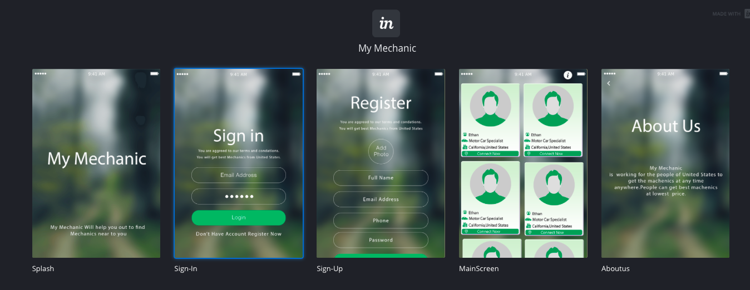

Features1

**Homepage page:** Home page should have basic detail that describes the app what is about

with Picture and text. This will take 30 min to complete and assigned to

team member Habtom Asfaha

Features2

**Sign-in page:** User and Admin shall be able to login. This will take about 1 hour and

assigned to team member Ermias Haile.

Features3

**Sign-up page:** User shall be able to sign up with full information. This will take 1 hour and

assigned to team member Habtom Asfaha.

Features4

**MainScreen page:** User shall be able to see all list of mechanic that added to the page by

admin. This will take 1 hours andassigned to Team member Ermias Haile

Features4

**About us page:** User shall be able to see and read about us page. This assigned to team

member Ermias Haile should have a similar work-load

**Milestone 2:**

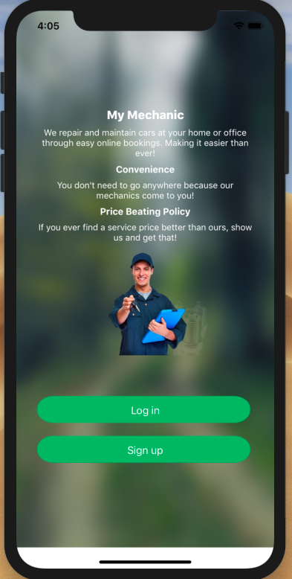 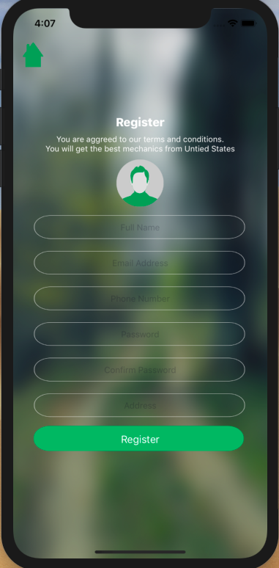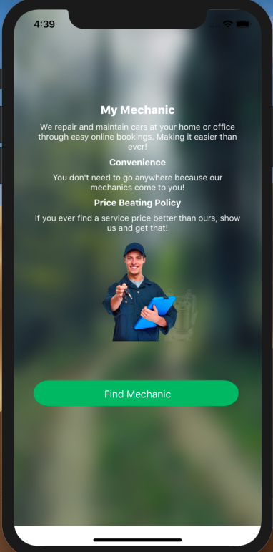

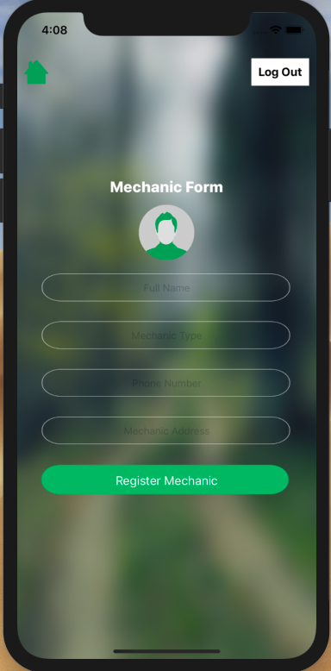 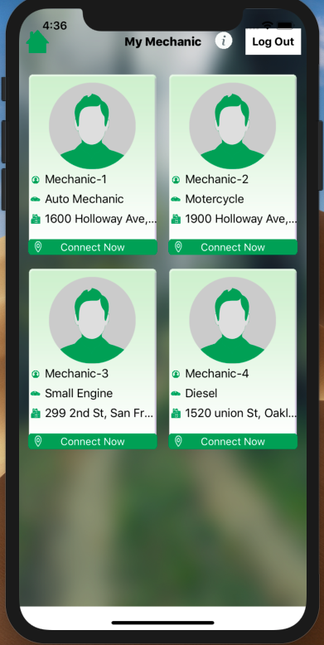

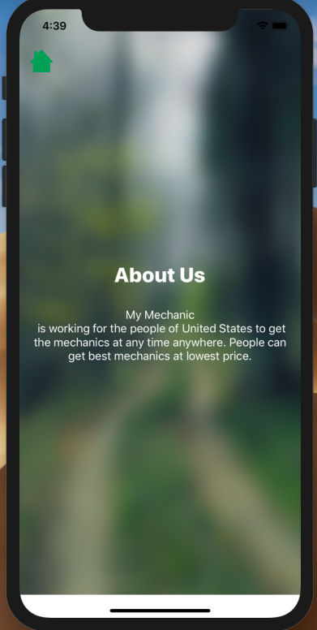

Features5

**Homepage page:** Shal have sign up and log-in button together, and mechanic picture along

with text. This will take 30 min to complete and assigned to team member

Habtom Asfaha

Features7

**Sign-up page:** Shall have password confirm and validation. This will take about 1 hour and

assigned to team member Ermias Haile.

Features8

**Find mechanic page:** App shall have Find mechainci page whit button which allow user to

click the button and that will take them to list of mechanic page. This

will take 1 hour and assigned to team member Habtom Asfaha.

Features9

**Log out and Home button: User and admin shall able to log out and go to home page form**

**each page.**  This will take 1 hours andassigned to Team member Ermias Haile

Features4

**About us page:** User shall be able to see and read about us page. This assigned to team

member Ermias Haile should have a similar work-load

**Additional Description:**

Wil develop this app in the feature by integrating with different API. In this project we have used the app to send text message to user. However, in future will implement Mechanic app for just mechanic and user will contact mechanic through that app instead of contacting them by text. This class give us opportunity to work this great idea. Thank you so much for teaching us.